**[P1][Sweet Escape][Homepage] When choosing a language other than EN, it is not translated to respective languages.**

**Description:**

When the tester change language from EN to others, tester noticed that all languages chosen is not translated at all to selected language

**Steps:**

1. Open website URL
2. Hover mouse to “EN” language selector
3. Change to any other languages

**Expected Result:**

Website reloaded and the content should be translated to each respective language.

**Actual Result:**

Website reloaded and the content is not translated to each respective language. Exceptions on ID, JA, KO, TH where “Cities” is translated to the respective language.

**Notes:**

* On ID, JA, KO, TH where “Cities” is translated to the respective language.
* Rest of the web contents is not translated at all

**Evidences:**

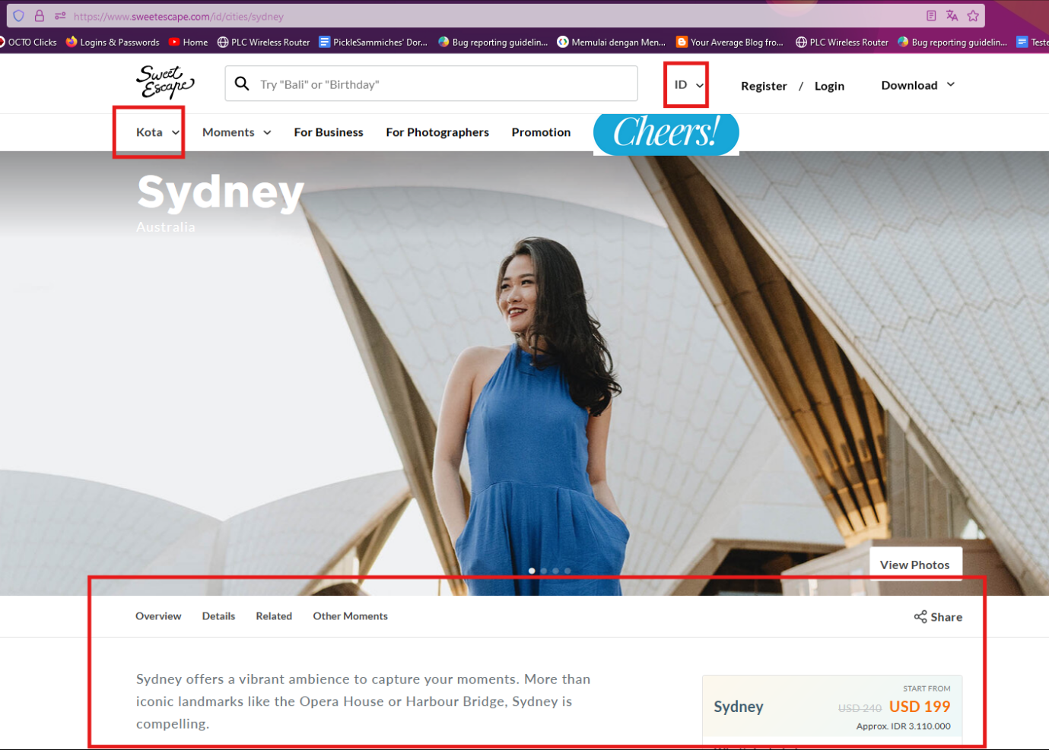

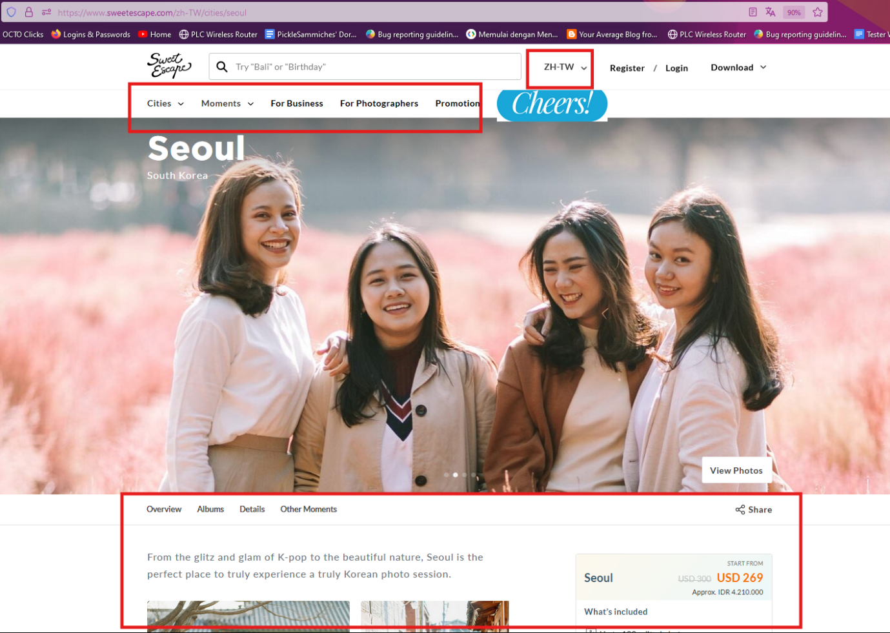

**[P2][Sweet Escape][Homepage] When click Download for iOS/Android link, only redirect to error page with message “app_not_found”**

**Description:**

When the tester click download for iOS or Android, the link redirects to empty page with error message “app_not_found”

**Steps:**

Open website URL

Hover mouse to Download.

Click either Download for iOS or Download for Android

**Expected Result:**

Link url should be redirect to the App Store or Playstore

**Actual Result:**

Link url redirect to empty page with error message “app_not_found”

**Notes:**

N/A

**Evidences:**

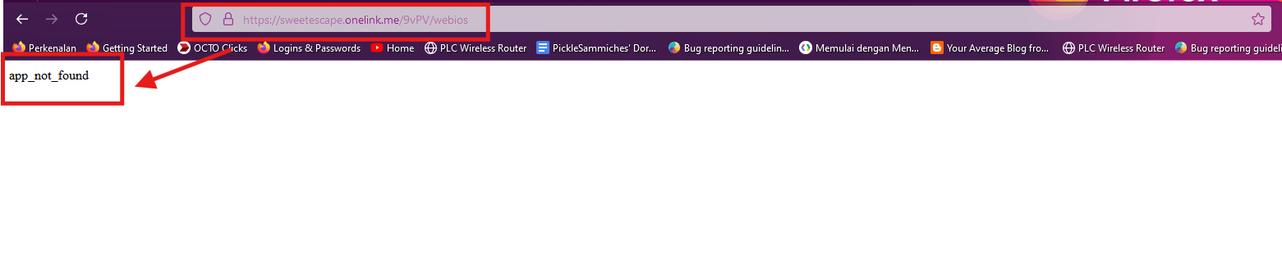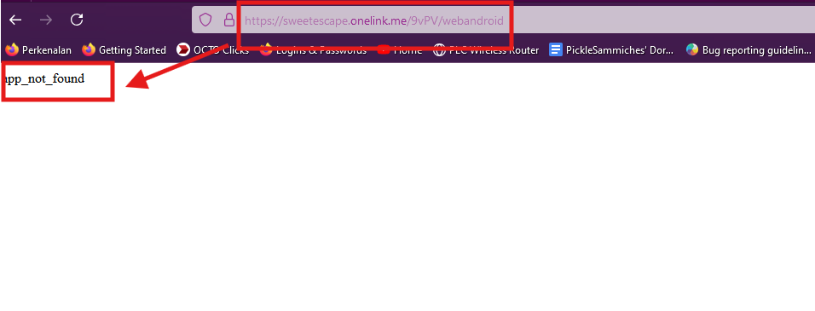

**[P2][Sweet Escape][Checkout] When click Use Credit slide button is not interactable.**

**Description:**

When the tester clicks the Use Credit slide button, the tester cannot see the button is activated.

**Steps:**

1. Open website url
2. Login with valid credentials
3. Return to homepage
4. Hover mouse to Cities
5. Click New York
6. Click Select a Moment
7. Choose one of the moment on dropdown menu
8. Click Check Availability button
9. Click Select button on 2 Hour Photo Shoot Package
10. Choose Date
11. Choose Time
12. Input Pax numbers
13. Choose Location
14. Input Details
15. Input Additional Details
16. Click Checkout button
17. Click Use Credit slide button

**Expected Result:**

Use Credit Slide button should be activated

**Actual Result:**

Use Credit Slide button is not activated

**Notes:**

* There is possibility that the button cannot be activated if user has zero Credit value

**Evidences:**

* [Unable to click Use Credit.mp4](https://drive.google.com/file/d/1HV27xDbI2NrOnVALL1GkyjHn4enrs5fy/view?usp=sharing)

**[P2][Automation][Sweet Escape][Registration] Cannot click any country list when running an automation script.**

**Description:**

When the tester runs an automated test for Registration flow, at Registration details the country list css cannot be clicked by the script.

**Steps:**

1. Run liveCoding.js script.
2. Wait until the Registration Flow process.
3. Noticed that the terminal gives error message that the .css for country selection is not found

**Expected Result:**

The script can select countries based on the css code.

**Actual Result:**

The script is unable to find the css code for countries selection.

**Notes:**

* Possibility of lack of automation experience by tester. However, the rest of the selection list is working flawlessly.

**Evidences:**

* [cannot select country automation.mp4](https://drive.google.com/file/d/1U5oCqtAkRe42zvZSvzLipLXAW5ymtxt0/view?usp=sharing)